A.5.M1 • PART 1

1. Basic network concepts
Goal: to recognize the types of networks and the basic equipment.

What is a computer network?
A computer network is a group of two or more devices that are connected so that they can exchange data and share resources, such as files, applications, printers, and Internet access.
Device A | → | Network | → | Device B

LAN, WAN and the Internet
Term | Area | Example
LAN (Local Area Network) | Small: room, building or nearby buildings | School laboratory
WAN (Wide Area Network) | Large: cities or countries | A company's network in many cities
Internet | Global interconnection of many networks | The largest WAN

The basic network devices
Device | Role
NIC / network card | Connects a device wired (RJ45) or wirelessly (Wi‑Fi).
Switch | Connects many wired devices on the same LAN.
Access Point | Connects wireless devices to the LAN.
Router | Connects different networks and forwards the data.
Modem | Adapts the signal for connection with the Internet provider.

Note:
At home, modem, router, switch and access point are often found inside the same device.

Client–Server
Client requests a service | → | Server provides a service
Example: the browser is a client and requests a web page from a web server.
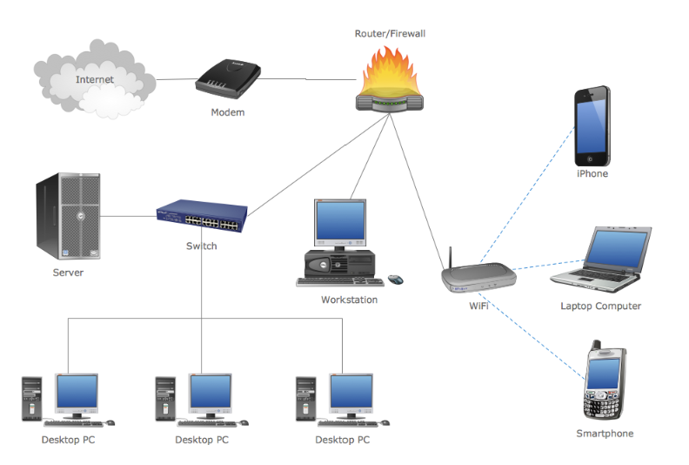  Example of a mixed network with wired and wireless devices. | 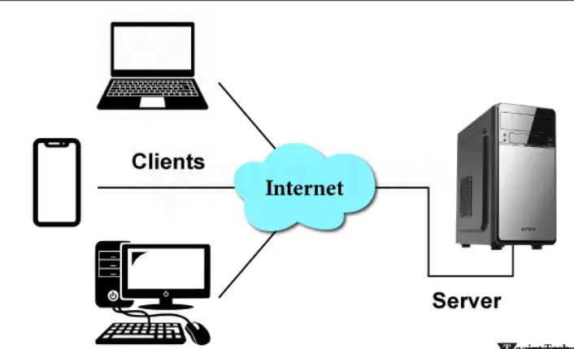  Clients connecting to a server via the Internet.

A.5.M1 • PART 2

2. Connections, speed and services
Goal: to choose an appropriate connection medium and distinguish basic Internet services.

Transmission media
Medium | How it transfers data | Advantages | Limitations
Cat 5 / Cat 6 cable | Electrical pulses | Stable connection, low cost | Up to about 100 m, needs RJ45
Optical fiber | Light pulses | Very high speed, many km | Higher cost, more difficult installation
Wi‑Fi | Electromagnetic waves | Freedom of movement, easy connection | Interference, obstacles, needs security

Data transfer speed
It measures how many bits are transferred every second. The speed depends on the device and the transmission medium.
1 Kbps ≈ 1,000 bps | → | 1 Mbps ≈ 1,000,000 bps | → | 1 Gbps ≈ 1,000,000,000 bps

Don't confuse:
b = bit, while B = byte. Network speed is usually written in bps, Mbps or Gbps.

Basic Internet services
Service | Abbreviation / protocol | What it does
World Wide Web | WWW / HTTP | Transfers web pages between web servers and browsers.
Electronic mail | E‑mail | Transfers electronic messages between users.
File transfer | FTP | Sends files from client to server and vice versa.

How do I choose a connection?
- Do I need stability and have a short distance? → Network cable.
- Do I need very high speed or long distance? → Optical fiber.
- Do I need mobility? → Wi‑Fi, with a strong password and correct security settings.
Quick check
Can you explain why a school laboratory is a LAN? Which medium would you choose to connect two buildings at a long distance?

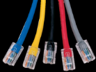  Network cables with RJ45. | 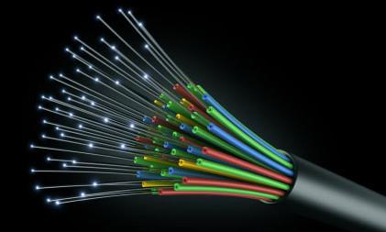  Optical fibers: transmission with light. | 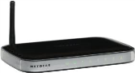  Wireless router / access point.

A.5.M2

3. Network settings and diagnostics
Goal: to read the settings of a device and perform basic checks.

The four basic settings
Setting | What it means | Example
IP Address | The unique address of the device on the network. | 192.168.10.23
Subnet Mask | Shows which part of the IP belongs to the network. | 255.255.255.0 (/24)
Default Gateway | The IP of the router towards other networks. | 192.168.10.1
DNS Server | Converts a website name into an IP Address. | www.example.com → 93.184.216.34

What is a subnet?
A subnet (subnetwork) is a group of devices with a common network portion. With mask 255.255.255.0 (/24), the first three parts of the IP indicate the network.
Device | IP Address | Result
PC A | 192.168.1.10 | Network 192.168.1.0
PC B | 192.168.1.25 | Same subnet — direct communication
Laptop | 192.168.2.10 | Different subnet — needs router/gateway

Diagnostic commands in Windows
Command | What it checks | Example
ipconfig /all | IP, mask, gateway and DNS of the device. | ipconfig /all
nslookup | Which DNS is used and which IP corresponds to a name. | nslookup example.com
ping | Whether a destination responds on the network. | ping 192.168.1.1
tracert | The intermediate routers (hops) to the destination. | tracert google.com

Correct order of checks
1. Cable / Wi‑Fi | → | 2. ipconfig | → | 3. ping router | → | 4. ping Internet | → | 5. DNS / tracert

- ping 8.8.8.8: checks Internet without needing name translation by DNS.
- ping www.google.com: checks both Internet connection and DNS.
- The commands display information; they do not change the settings.
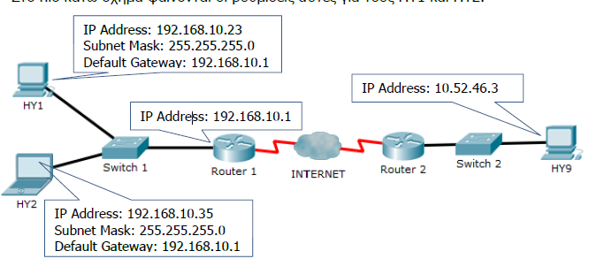
Example of IP Address, Subnet Mask and Default Gateway in two networks.

A.5.M5

4. Security and responsible communication
Goal: to recognize protection tools, dangerous messages and safe reactions.

Three tools — three different roles
Tool | Checks | Protects against
Antivirus | Files and applications | Viruses and other malware
Firewall | Network traffic and access rules | Suspicious or unauthorized connections
Antispyware | Hidden monitoring and data collection | Spyware

Social networks and personal data
What do I share? | → | Who sees it? | → | What remains?
Address, phone number, school, location and photos require caution. Privacy settings limit the audience, but do not always prevent copying. What we publish creates a digital footprint.

Phishing: four warning signs
1 | 2 | 3 | 4
Suspicious sender | Pressure or "urgency" | Asks for password or personal details | Strange domain / link

Safe reaction:
Do not click the link. Open the official app or website ourselves and inform a responsible person.

Grooming and Cyberbullying
Risk | Signs | What I do
Grooming | Fake identity, gradual trust, secrecy, request for photos or meeting. | Stop communication and talk immediately to a trusted adult.
Cyberbullying | Repeated insults, threats or publishing content without permission. | Do not reply, keep evidence, block, report and ask for help.

Final review check
- Explain the difference between antivirus and firewall.
- Mention two signs of phishing.
- State four actions for dealing with cyberbullying.
- Give an example of personal data that should not be published.
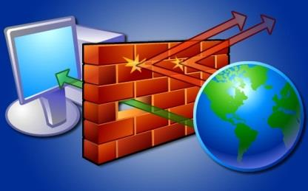
The firewall filters traffic between the device and the network.

